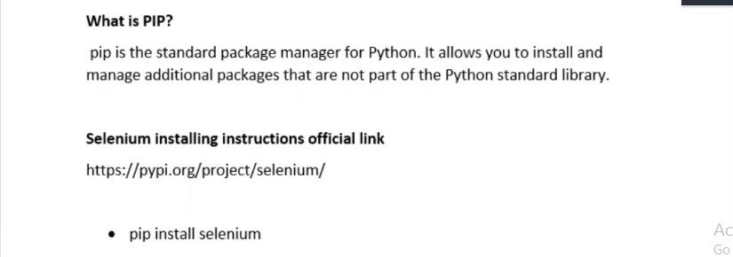

* In Python all the utilities we use are known as packages. In java it is called jars.

Eg: Python testing framework packages, selenium packages.

* PIP is responsible to maintain all those packages.
* If selenium packages are downloaded they are placed in python library automatically. PIP does it.
* But in java there are two separate instances: Java and selenium jars. In Python automatically the packages will be injected.
* pip is downloaded by default when we download python. In my case pathe is : “C:\Users\HP\AppData\Local\Programs\Python\Python38-32\Scripts”.

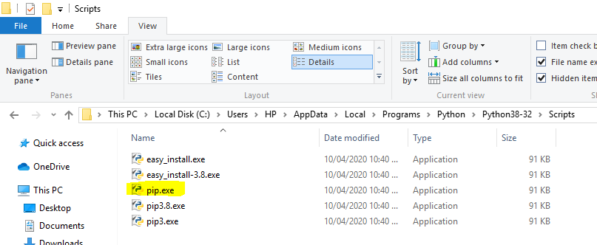

* We have configured it in Path variable as the computer should know where it is during using pip command.
* How to download selenium packages?

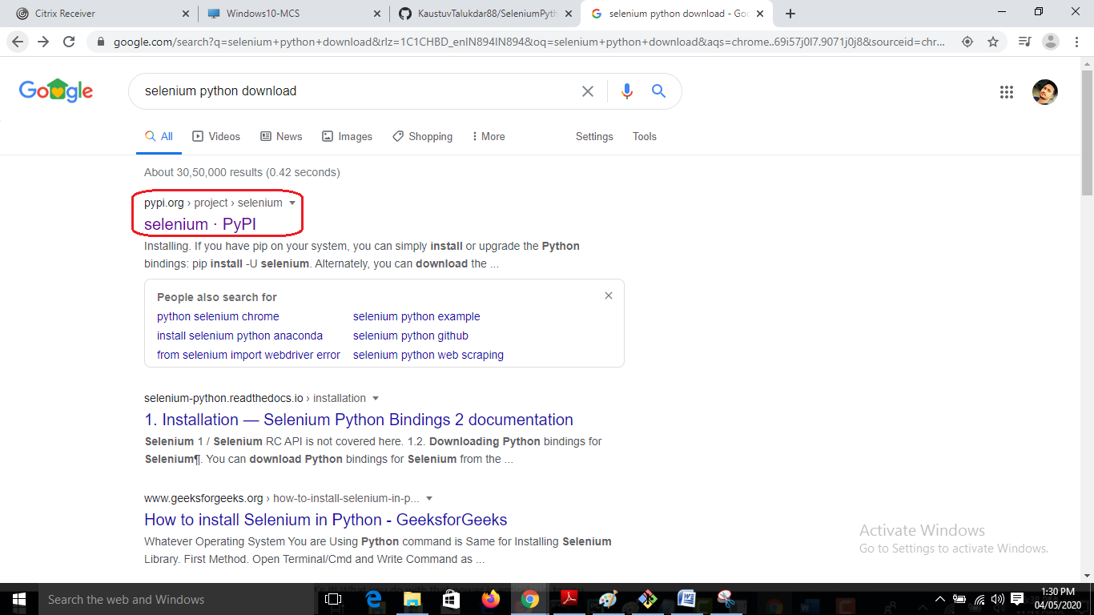

* Copy the below and open command prompt.

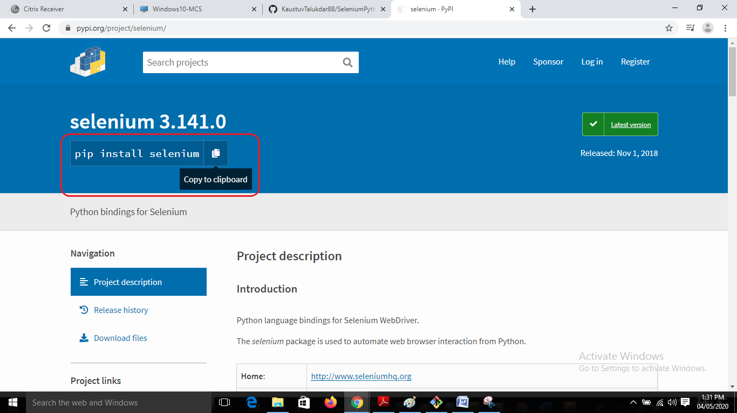

* Open cmd and paste

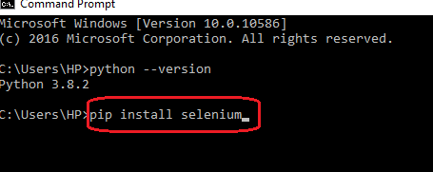

* Hit enter.

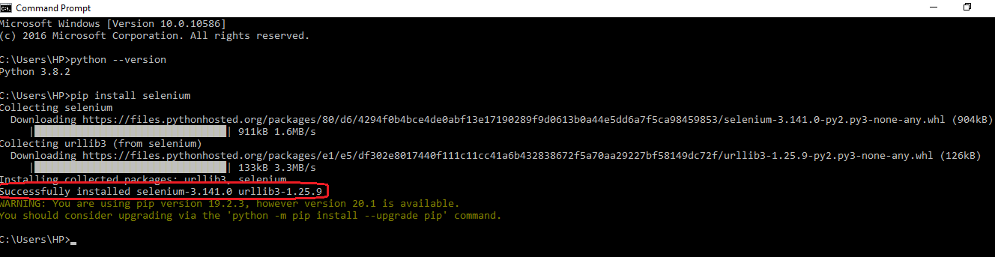

* Selenium got installed. Check in the below folder: “C:\Users\HP\AppData\Local\Programs\Python\Python38-32\Lib\site-packages\selenium”

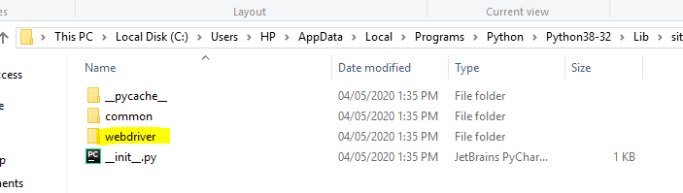

* We check using below command also, whether selenium is installed or not:

Pip show selenium > Enter

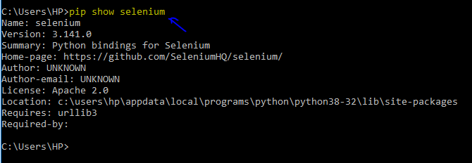

* Note from instructor, screenshot

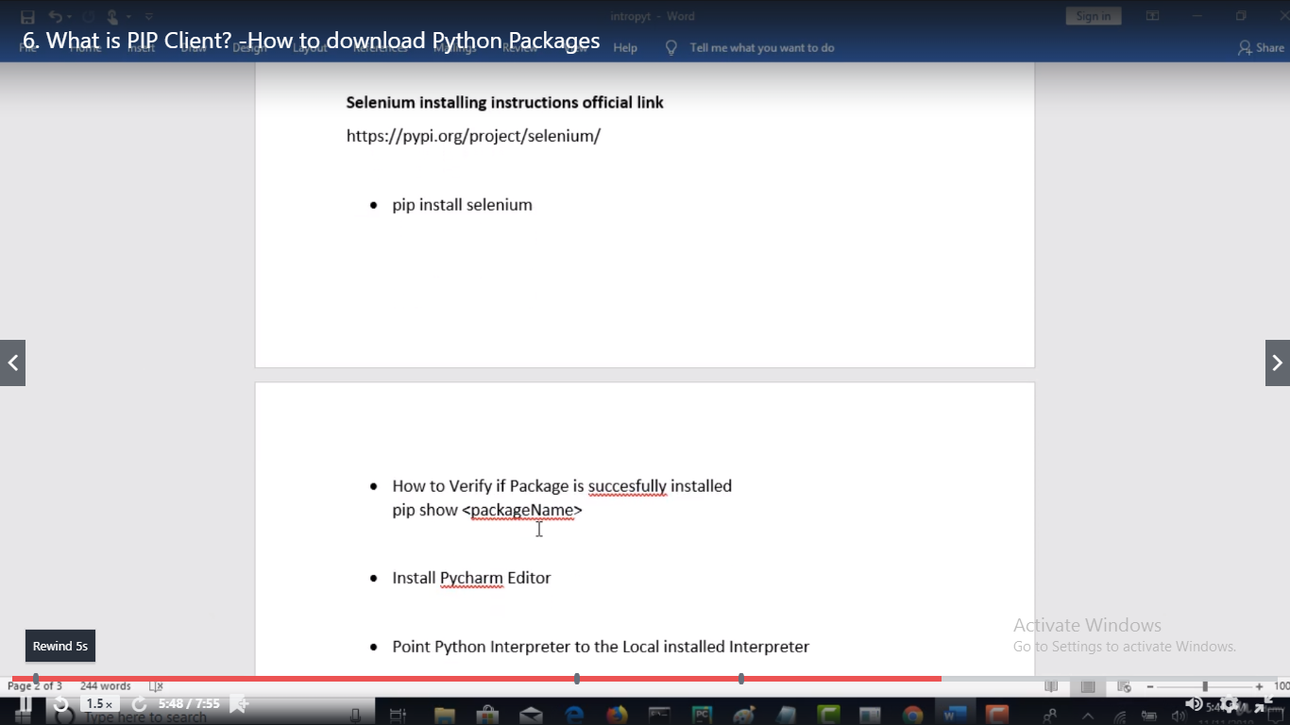

* Please note we will be using PyCharm editor.
* Download community PyCharm.

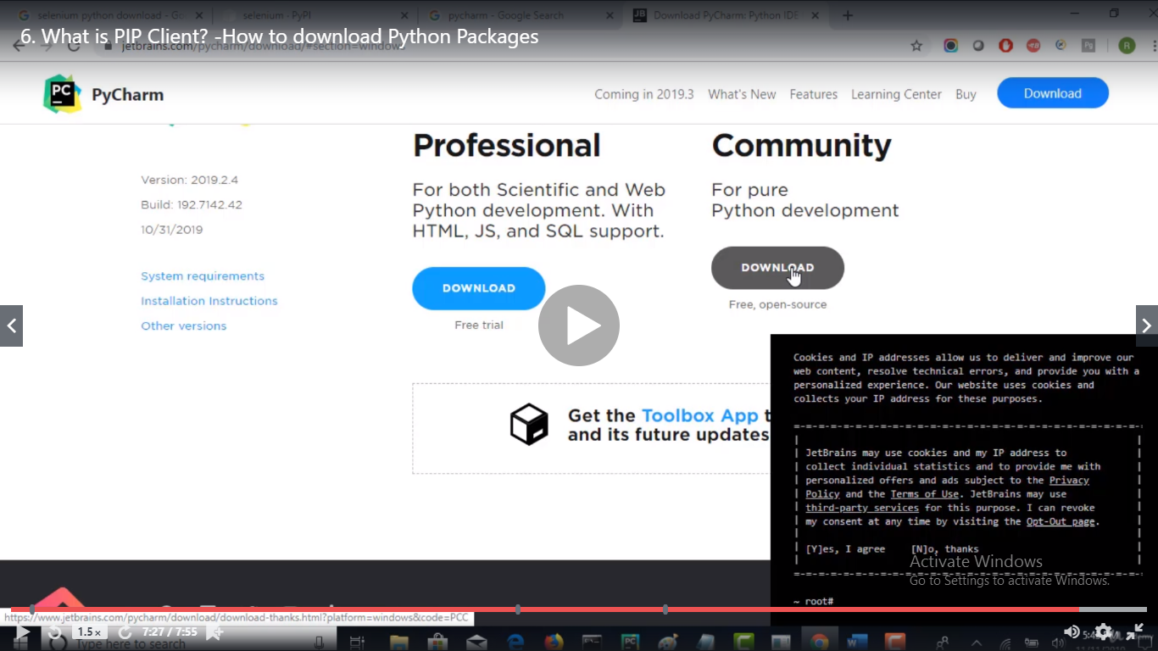

* Note
* Python, Selenium Installation Guide Download
* Installing Python and Selenium
* **Installing Python**:
* Windows : <http://python.org/download/>.
* Note : IF you are using Linux, MacOS X, Unix operating Systems then python will be installed by default with OS
* 1.**What is PIP installer Tool?**  
  pip is a package management system used to install and manage software packages written in Python  
  pip is a recursive acronym that can stand for either "Pip Installs Packages" or "Pip Installs Python
* 2.**Where do we get this PIP Tool?** And how to configure it in our Local Machines
* 3.**Installing Selenium**  
  Use Below command on PIP to install Selenium Package  
  **pip install selenium**
* This command will set up the Selenium WebDriver client library on your machine with all modules and classes that we will need to create automated scripts using Python
* 4.**pip install -U selenium**  
  The optional –U flag will upgrade the existing version of the installed package